Open Surface

Definition
# Source: AI Source: Provided by: [Data Path: Persons Table -> ID Column: 1, Name_En Column: Motasem Essam] -> From: [ChatGPT] on [7/20/2026]
An open surface is a surface that has a boundary or does not form a complete enclosure around a three-dimensional region.
Unlike a closed surface, an open surface does not completely separate an interior region from the exterior.
Examples include:
- The lateral surface of a cylinder without its bases
- The curved surface of a hemisphere without its circular base
- A plane surface bounded by an edge
- A sheet-like surface
- The lateral surface of a cone without its base
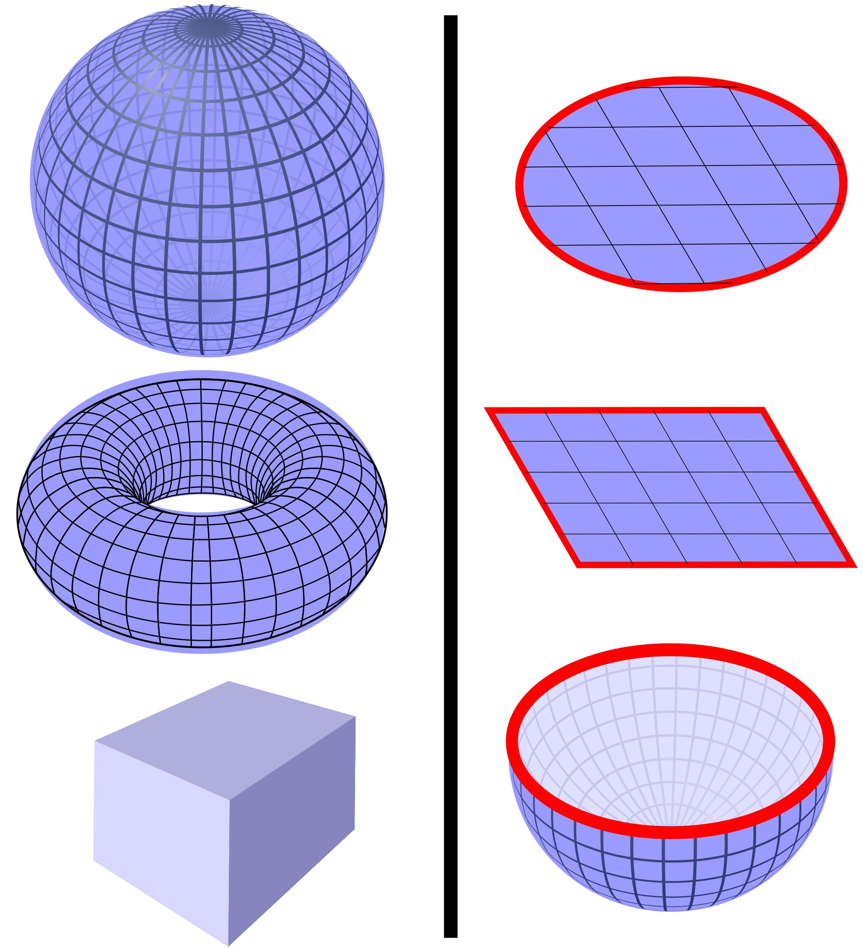
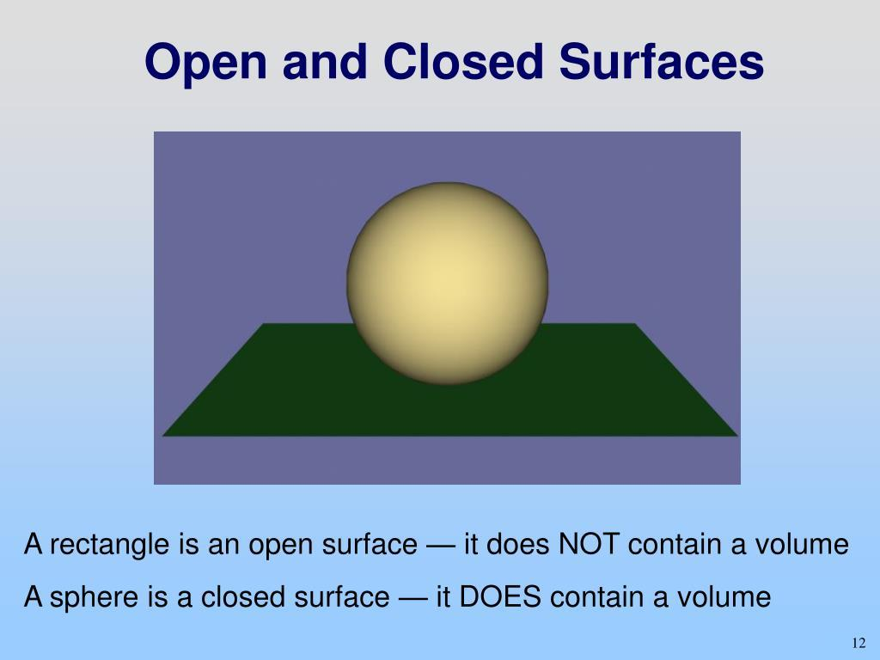
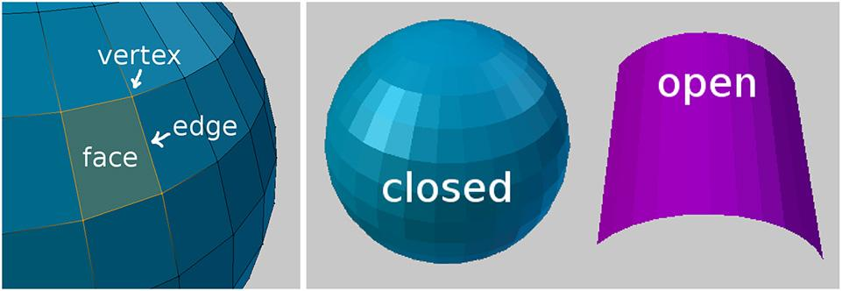

Purpose
# Source: AI Source: Provided by: [Data Path: Persons Table -> ID Column: 1, Name_En Column: Motasem Essam] -> From: [ChatGPT] on [7/20/2026]
The concept of an open surface is used to:
- Describe incomplete boundaries of three-dimensional objects.
- Study surfaces that have one or more boundary curves or edges.
- Calculate lateral surface area or curved surface area.
- Model sheets, membranes, walls, and shells.
- Distinguish partial surfaces from complete closed surfaces.
- Study surfaces in geometry, calculus, physics, and engineering.

Fundamental Characteristics

1. Has a Boundary
# Source: AI Source: Provided by: [Data Path: Persons Table -> ID Column: 1, Name_En Column: Motasem Essam] -> From: [ChatGPT] on [7/20/2026]
The defining characteristic of an open surface is that it has a boundary.
The boundary may be:
- A line segment
- A closed curve
- Several curves
- Several edges
For example, the curved lateral surface of a cylinder has two circular boundary curves.
$$\boxed{∂S≠∅}$$
where $∂S$represents the boundary of the surface.

2. Does Not Form a Complete Enclosure
# Source: AI Source: Provided by: [Data Path: Persons Table -> ID Column: 1, Name_En Column: Motasem Essam] -> From: [ChatGPT] on [7/20/2026]
An open surface does not completely enclose a three-dimensional region.
For example, a cylindrical surface without its circular bases does not completely contain an interior.
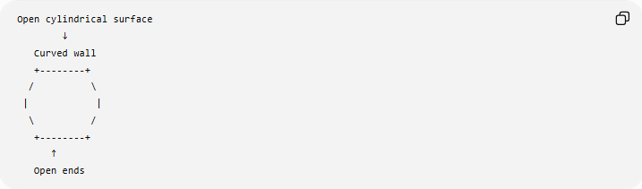
Open cylindrical surface
↓
Curved wall
+--------+
/ \
| |
\ /
+--------+
↑
Open ends

3. Can Be Flat or Curved
# Source: AI Source: Provided by: [Data Path: Persons Table -> ID Column: 1, Name_En Column: Motasem Essam] -> From: [ChatGPT] on [7/20/2026]
Being open does not necessarily mean that a surface is curved.
An open surface can be:
- Plane
- Curved
This is an important distinction.
For example:
$$\boxed{\text{Open/Closed}≠\text{Plane/Curved}}$$
These are two different ways of classifying surfaces.

Examples of Open Surfaces

1. Cylindrical Lateral Surface
# Source: AI Source: Provided by: [Data Path: Persons Table -> ID Column: 1, Name_En Column: Motasem Essam] -> From: [ChatGPT] on [7/20/2026]
The lateral surface of a cylinder without its two circular bases is an open surface.
For a cylinder with radius $r$and height $h$:
$$CSA=2πrh$$
The two circular boundaries remain open.
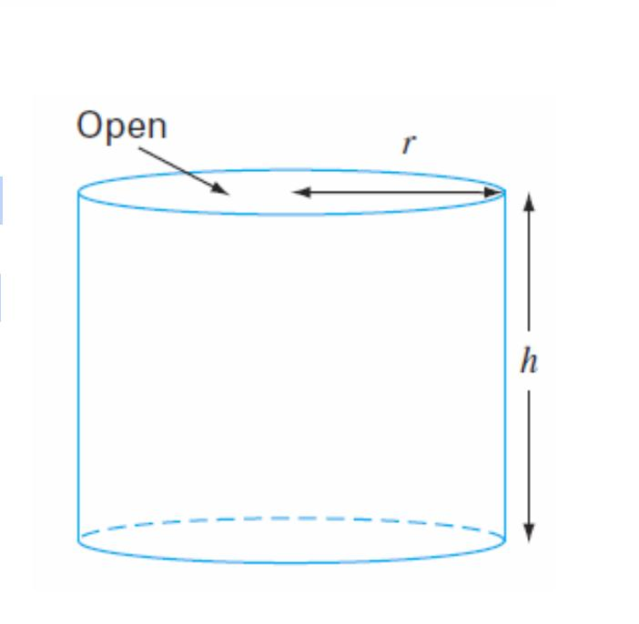
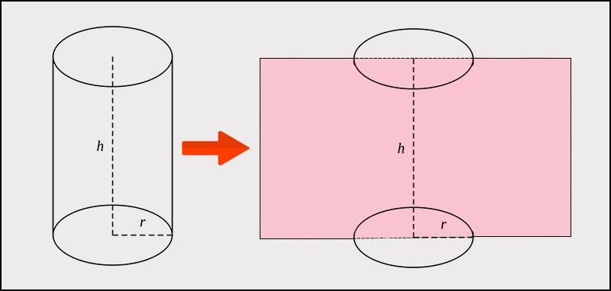
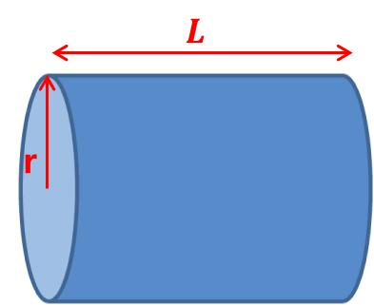

2. Conical Lateral Surface
# Source: AI Source: Provided by: [Data Path: Persons Table -> ID Column: 1, Name_En Column: Motasem Essam] -> From: [ChatGPT] on [7/20/2026]
The curved lateral surface of a cone without its circular base is an open surface.
For radius $r$and slant height $l$:
$$CSA=πrl$$
The circular base is the boundary of the lateral surface.
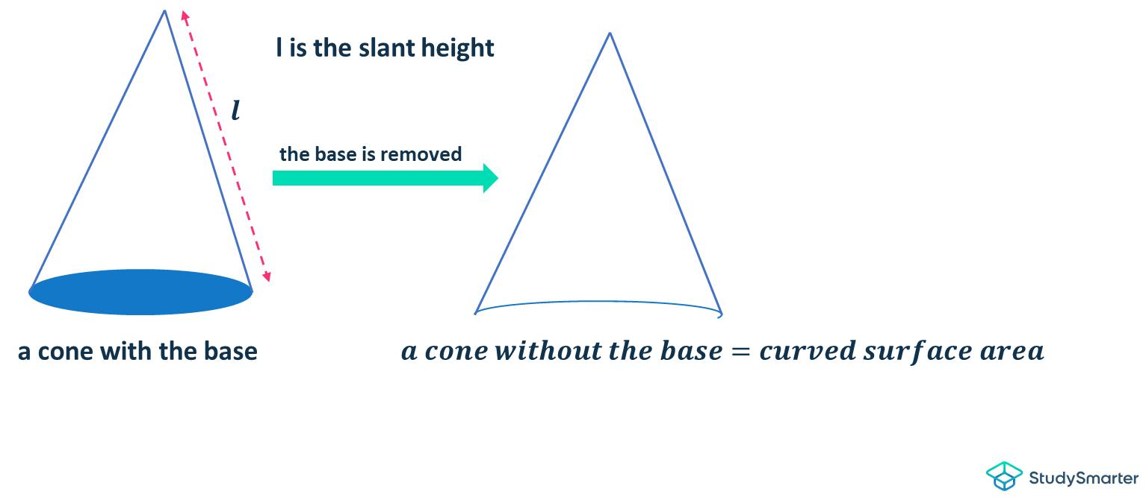
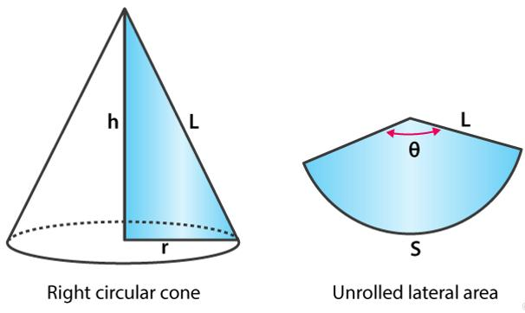
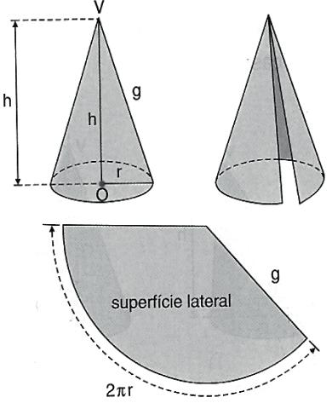

3. Hemispherical Curved Surface
# Source: AI Source: Provided by: [Data Path: Persons Table -> ID Column: 1, Name_En Column: Motasem Essam] -> From: [ChatGPT] on [7/20/2026]
The curved surface of a hemisphere without its circular base is open.
For radius $r$:
$$CSA=2πr^{2}$$
The circular edge forms the boundary.
If the circular base is added, the complete surface becomes closed:
$$TSA=3πr^{2}$$
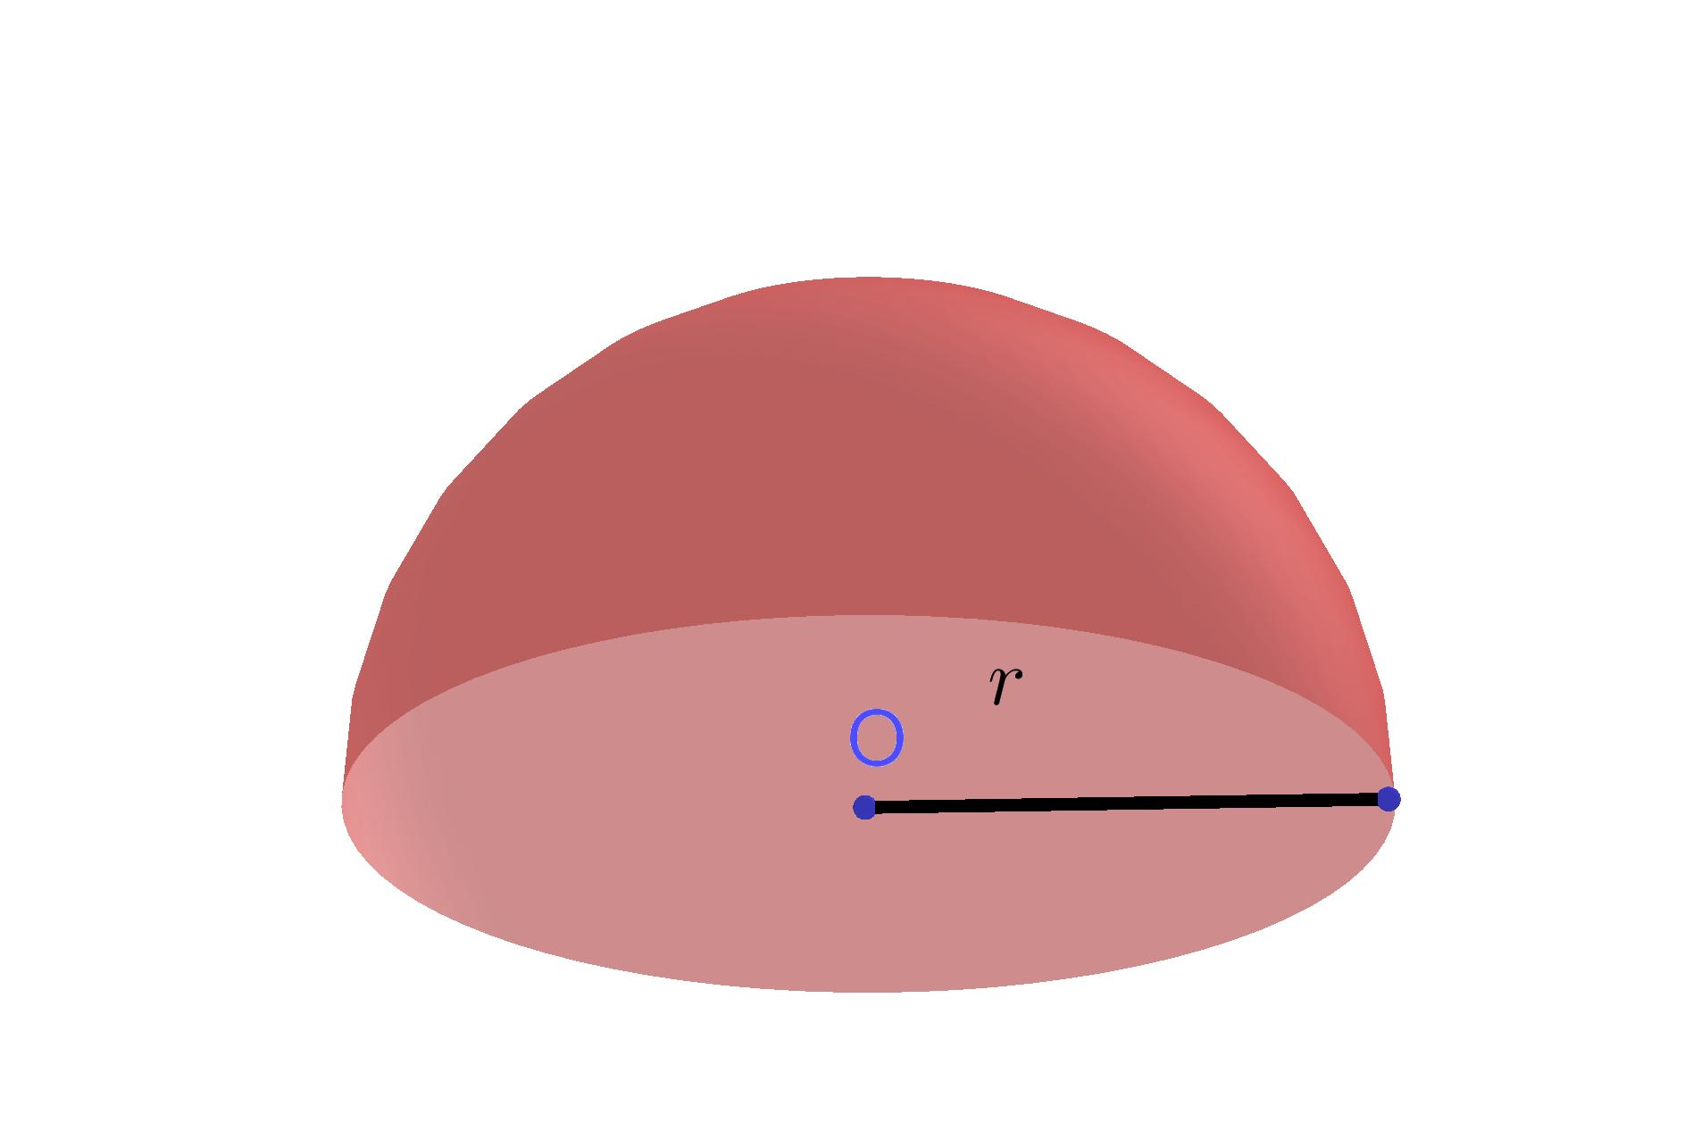
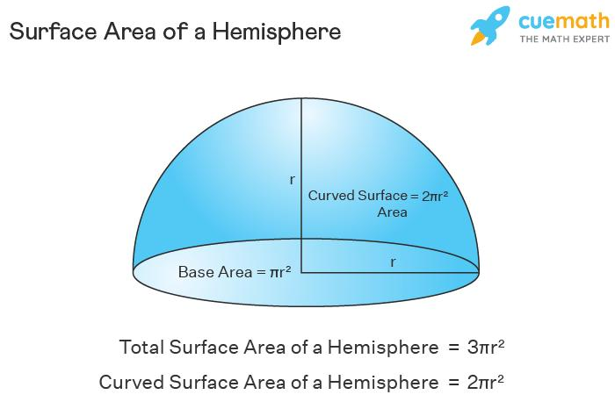
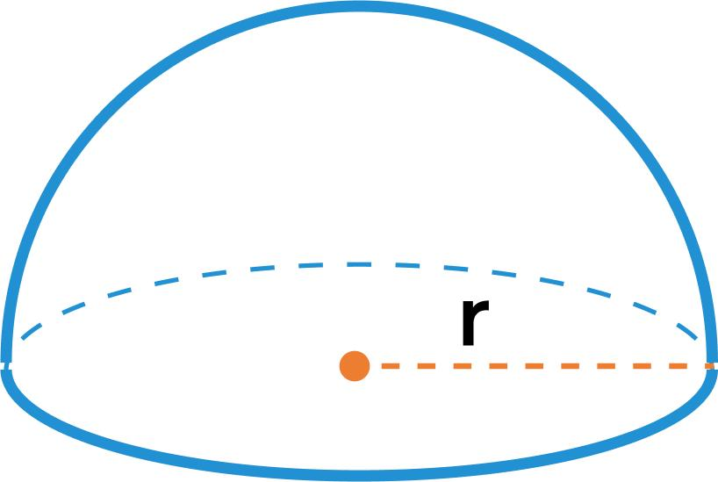

4. Plane Surface with a Boundary
# Source: AI Source: Provided by: [Data Path: Persons Table -> ID Column: 1, Name_En Column: Motasem Essam] -> From: [ChatGPT] on [7/20/2026]
A finite flat region, such as a rectangular sheet, has a boundary.
For example, a rectangular sheet has four boundary edges:
$$AB, BC, CD, DA$$
The sheet itself is a surface with a boundary.
This demonstrates that an open surface does not have to be curved.

Mathematical Representation
# Source: AI Source: Provided by: [Data Path: Persons Table -> ID Column: 1, Name_En Column: Motasem Essam] -> From: [ChatGPT] on [7/20/2026]
For a surface $S$, its boundary can be represented by:
$$∂S$$
For an open surface:
$$\boxed{∂S≠∅}$$
For a closed surface:
$$\boxed{∂S=∅}$$
This provides a mathematical distinction between the two classifications.

Open Surface Area
# Source: AI Source: Provided by: [Data Path: Persons Table -> ID Column: 1, Name_En Column: Motasem Essam] -> From: [ChatGPT] on [7/20/2026]
The area of an open surface is measured by its surface area.
Depending on the surface, the appropriate formula differs.
Cylinder — Lateral Surface
$$A=2πrh$$
Cone — Lateral Surface
$$A=πrl$$
Hemisphere — Curved Surface
$$A=2πr^{2}$$
The important point is that only the specified surface is measured.

Example
# Source: AI Source: Provided by: [Data Path: Persons Table -> ID Column: 1, Name_En Column: Motasem Essam] -> From: [ChatGPT] on [7/20/2026]
Consider an open cylinder with:
$$r=4\text{ cm}$$
and:
$$h=10\text{ cm}$$
Suppose the two circular bases are not included.
The area of the open curved surface is:
$$A=2πrh \\ A=2π\left(4\right)\left(10\right) \\ \boxed{A=80π{\text{ cm}}^{2}}$$
Approximately:
$$A≈251.33{\text{ cm}}^{2}$$

Open Surface vs Closed Surface
# Source: AI Source: Provided by: [Data Path: Persons Table -> ID Column: 1, Name_En Column: Motasem Essam] -> From: [ChatGPT] on [7/20/2026]
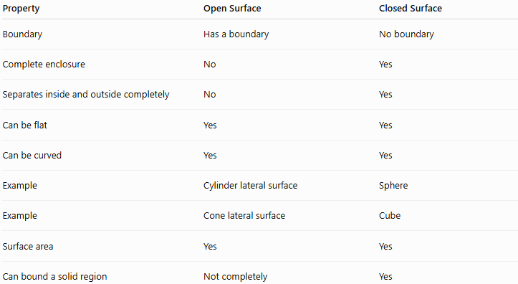
Property | Open Surface | Closed Surface
Boundary | Has a boundary | No boundary
Complete enclosure | No | Yes
Separates inside and outside completely | No | Yes
Can be flat | Yes | Yes
Can be curved | Yes | Yes
Example | Cylinder lateral surface | Sphere
Example | Cone lateral surface | Cube
Surface area | Yes | Yes
Can bound a solid region | Not completely | Yes
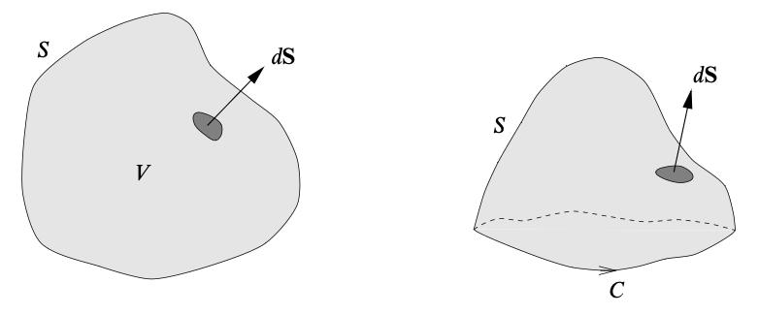

Open Surface vs Curved Surface
# Source: AI Source: Provided by: [Data Path: Persons Table -> ID Column: 1, Name_En Column: Motasem Essam] -> From: [ChatGPT] on [7/20/2026]
These terms should not be treated as opposites.
An open surface can be curved:
$$\boxed{\text{Cylinder lateral surface}=\text{Curved + Open}}$$
An open surface can also be flat:
$$\boxed{\text{Finite plane region}=\text{Plane + Open}}$$
Likewise, a surface can be curved and closed:
$$\boxed{\text{Sphere}=\text{Curved + Closed}}$$
This gives two independent classifications:
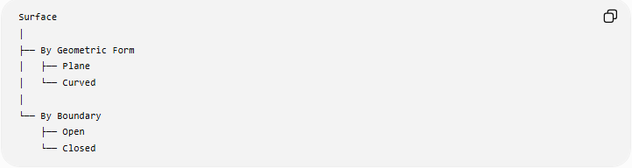
Surface
│
├── By Geometric Form
│ ├── Plane
│ └── Curved
│
└── By Boundary
├── Open
└── Closed

Relationship with Related Concepts
# Source: AI Source: Provided by: [Data Path: Persons Table -> ID Column: 1, Name_En Column: Motasem Essam] -> From: [ChatGPT] on [7/20/2026]
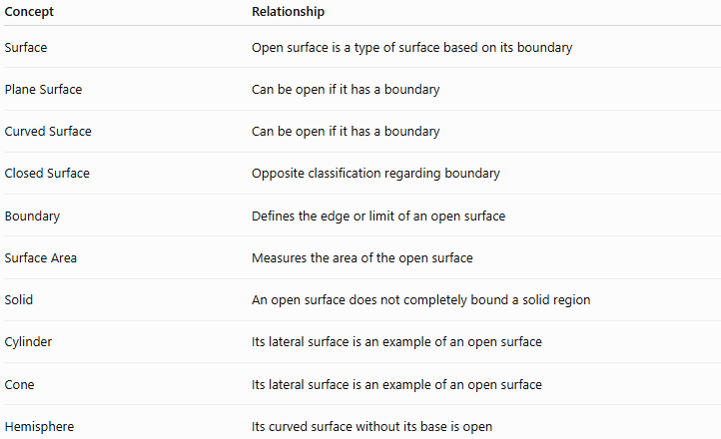
Concept | Relationship
Surface | Open surface is a type of surface based on its boundary
Plane Surface | Can be open if it has a boundary
Curved Surface | Can be open if it has a boundary
Closed Surface | Opposite classification regarding boundary
Boundary | Defines the edge or limit of an open surface
Surface Area | Measures the area of the open surface
Solid | An open surface does not completely bound a solid region
Cylinder | Its lateral surface is an example of an open surface
Cone | Its lateral surface is an example of an open surface
Hemisphere | Its curved surface without its base is open

Real-World Applications
# Source: AI Source: Provided by: [Data Path: Persons Table -> ID Column: 1, Name_En Column: Motasem Essam] -> From: [ChatGPT] on [7/20/2026]
Open surfaces are common in:
- Engineering
- Architecture
- Manufacturing
- Packaging
- Construction
- Mechanical design
- Computer graphics
- CAD
- Fluid mechanics
- Structural design
Examples include:
- Open pipes
- Roof surfaces
- Sheets of metal
- Fabric membranes
- Open containers
- Cylindrical walls
- Conical funnels before their bases are considered

Important Terminology
# Source: AI Source: Provided by: [Data Path: Persons Table -> ID Column: 1, Name_En Column: Motasem Essam] -> From: [ChatGPT] on [7/20/2026]
There is a subtle distinction between open surface and open solid.
Open Surface
Describes the surface itself and its boundary.
Open Solid
Usually describes a three-dimensional region or object that is not completely enclosed.
Therefore, in your knowledge base, keep them as separate concepts:
Surface
└── Open Surface

Solid
└── Open Solid

Key Points
# Source: AI Source: Provided by: [Data Path: Persons Table -> ID Column: 1, Name_En Column: Motasem Essam] -> From: [ChatGPT] on [7/20/2026]
- An open surface has a nonempty boundary.
- It does not form a complete enclosure.
- It can be flat or curved.
- The lateral surface of a cylinder is a common example.
- The lateral surface of a cone is another example.
- The curved surface of a hemisphere without its base is open.
- A finite plane region can also be an open surface because it has a boundary.
- Open and closed classify a surface according to its boundary, while plane and curved classify it according to its geometric form.
- Mathematically:
$$\boxed{∂S≠∅}$$
for an open surface.

Conclusion
# Source: AI Source: Provided by: [Data Path: Persons Table -> ID Column: 1, Name_En Column: Motasem Essam] -> From: [ChatGPT] on [7/20/2026]
An open surface is a surface that has a boundary and therefore does not form a complete enclosure around a three-dimensional region. It may be either plane or curved. Cylindrical and conical lateral surfaces are important examples. For your knowledge-base taxonomy, Open Surface and Closed Surface should be classified under "By Boundary," while Plane Surface and Curved Surface should be classified under "By Geometric Form."
Would you like the next entry to cover Plane Surface or Curved Surface?

